**Practical No 9**

**Aim :** Develop, debug and execute a C program to simulate FIFO page replacement algorithms.

**Apparatus:** Mingw compiler for C/C++, and a text editor for developing C code file (Dev C++).

**Theory :**

**What is Page Replacement algorithm?**

* In an operating system that uses paging for memory management, a page replacement algorithm is needed to decide which page needs to be replaced when new page comes in.
* The page replacement algorithms do this task of deciding which page needs to be replaced when a new page arrives in the memory.

**What are the components of Page Replacement Algorithms?**

**Page fault:**

* A page fault happens when a running program accesses a memory page that is mapped into the virtual address space but is not loaded in physical memory.
* Since actual physical memory is much smaller than virtual memory, page faults can happen.
* In case of page faults, the operating system might have to replace one of the existing pages with the newly needed page.
* Different page replacement algorithms suggest different ways to decide which page to replace.
* The target for all algorithms is to reduce the number of page faults.

**Page Hit:**

* When we want to load the page on the memory, and the page is already available on memory, then it is called page hit.

**What is FIFO Page Replacement?**

* This is the Simplest page replacement algorithm.
* In this algorithm, the operating system keeps track of all pages in the memory in a queue, the oldest page is in the front of the queue.
* When a page needs to be replaced page in the front of the queue is selected for removal.

**Example:**

Reference string: 7,0,1,2,0,3,0,4,2,3,0,3,1,2,0

No of frames: 3

|  |  |  |  |  |  |  |  |  |  |  |  |  |  |  |  |  |
| --- | --- | --- | --- | --- | --- | --- | --- | --- | --- | --- | --- | --- | --- | --- | --- | --- |
| F3 |  |  | 1 | | 1 | 1 | 1 | 0 | 0 | 0 | 3 | 3 | 3 | 3 | 2 | 2 |
| F2 |  | 0 | 0 | | 0 | 0 | 3 | 3 | 3 | 2 | 2 | 2 | 2 | 1 | 1 | 1 |
| F1 | 7 | 7 | 7 | | 2 | 2 | 2 | 2 | 4 | 4 | 4 | 0 | 0 | 0 | 0 | 0 |
|  | * | * | | * | * | HIT | * | * | * | * | * | * | HIT | * | * | HIT |

Page fault (*): 12

Page hit (HIT): 3

Page fault ratio = No. of page fault / No. of reference string

= 12/15

= 80%

Page hit ratio = No. of page ratio / No. of reference string

= 3/15

= 20%

**Code:**

#include<stdio.h>

int main()

{

int i,j,n,a[50],frame[10],no,k,avail,count=0;

printf("\n Enter number of pages : ");

scanf("%d",&n);

for(i=1;i<=n;i++){

printf("\n Enter page number(%d) : ",i+1);

scanf("%d",&a[i]);

}

printf("\n Enter number of frames :");

scanf("%d",&no);

printf("\n");

for(i=0;i<no;i++)

frame[i]= -1;

j=0;

printf("ref string\t page frames\t\tPage Hit\\fault\n");

for(i=1;i<=n;i++){

printf("%5d\t\t",a[i]);

avail=0;

for(k=0;k<no;k++)

if(frame[k]==a[i])

avail=1;

if (avail==0){

frame[j]=a[i];

j=(j+1)%no;

count++;

}

for(k=0;k<no;k++){

if(frame[k] == -1)

printf(" \t");

else

printf("%d\t",frame[k]);

}

printf("%s",avail==1 ? "Page Hit" : "Page Fault");

printf("\n");

}

printf("Page Fault : %d\n",count);

printf("Page Hit : %d\n",n-count);

printf("Page fault ratio : %.02f%%\n",count/(float)n * 100);

printf("Page Hit ratio : %.02f%%\%\n",(n-count)/(float)n * 100);

return 0;

}

**Output:**

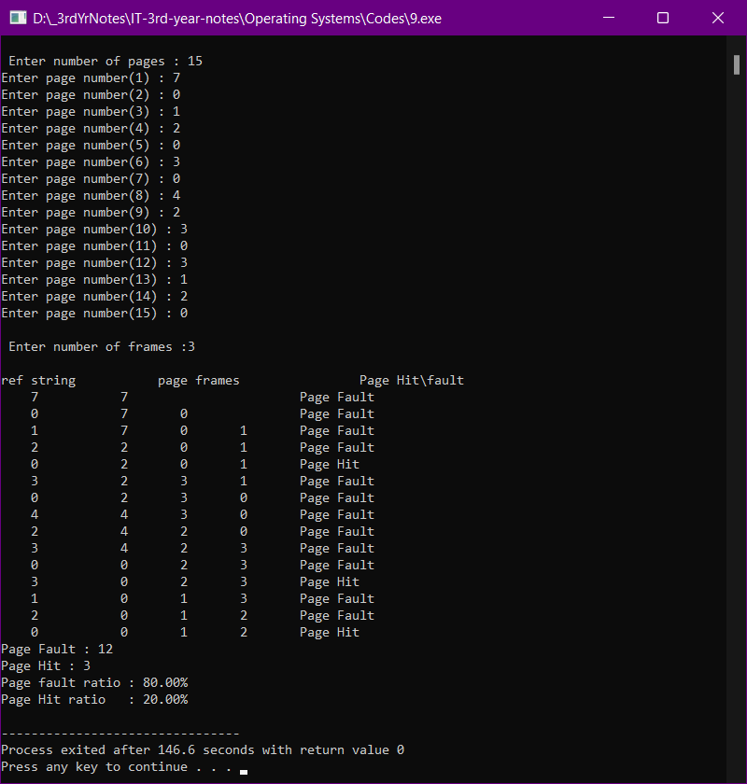

**Conclusion**:

Hence, by performing this practical I got to know about the concept of Page replacement, page fault and page hit. I also learnt about FIFO page replacement algorithm. I also developed, debugged and executed a C program to simulate FIFO page replacement algorithms.